SSH to your AWS Workstation.

1. Clone the Git-repo.

|  |
| --- |
| $ sudo su (password is Dev0p$!!/ ) # git clone https://github.com/LovesCloud/dotnet-angular-docker.git # cd dotnet-angular-docker # dotnet build # dotnet publish --self-contained -r linux-x64 -o dll |

2. Create a Dockerfile now.

|  |
| --- |
| # vim Dockerfile |

Add the below lines in the docker file

|  |
| --- |
| **FROM microsoft/dotnet:2.2-runtime WORKDIR /data/ COPY dll/ /data/  RUN chmod +x angular* EXPOSE 5001 EXPOSE 5000 EXPOSE 80 ENTRYPOINT ["./angular"]** |

**Save and exit the vim editor.**

3. Run the below commands to build a Docker Container from the git repo.

|  |
| --- |
| # docker build . -t docker.net.demo |

4. Check the Image after it has been build.

|  |
| --- |
| # docker images |

5. Run the docker container from the build image

|  |
| --- |
| # docker run -d -p 80:80 --name dotnet-app docker.net.demo  # docker ps |

The dotnet Docker Container running on port 80, and can be accessed from the public IP of the AWS Workstation on default Port 80

**http://<ip-addr-aws-workstation>**\

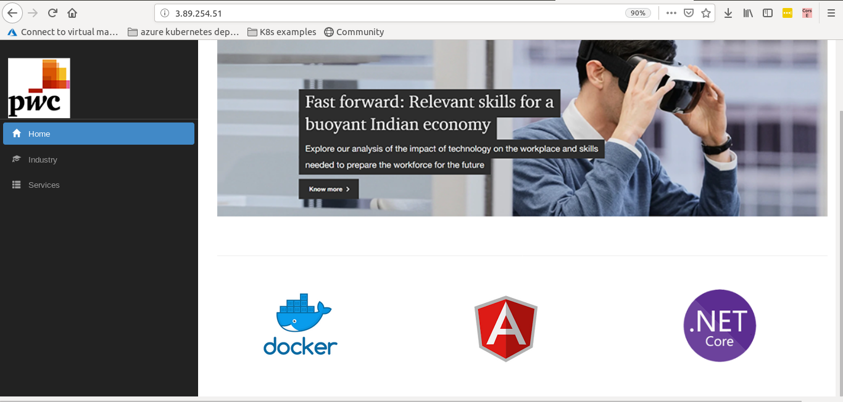

**STOP THE CONTAINER BEFORE PROCEEDING TO THE NEXT LAB**

6. Stop the docker container by running the below command.

|  |
| --- |
| # docker stop dotnet-app |